St Peter’s Bay 404

*St Peter*

6 Guests

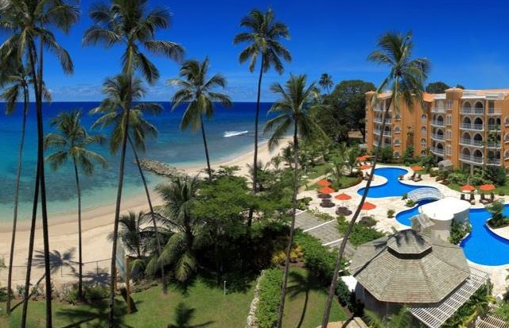

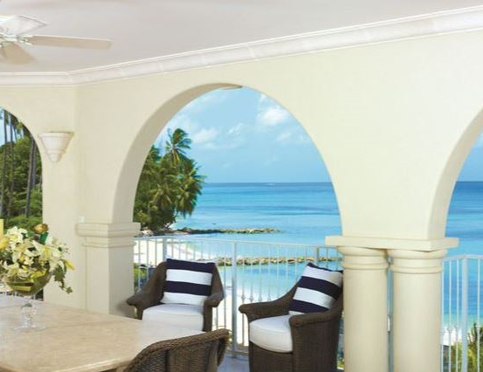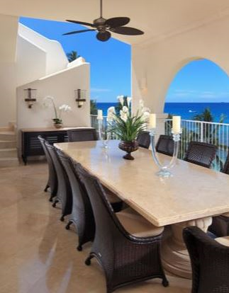

This three bedroom home features a Master suite and two ensuite bedrooms. Ocean views have been maximized with the design boasting sea views from the kitchen, living area, two terraces, and bedrooms.

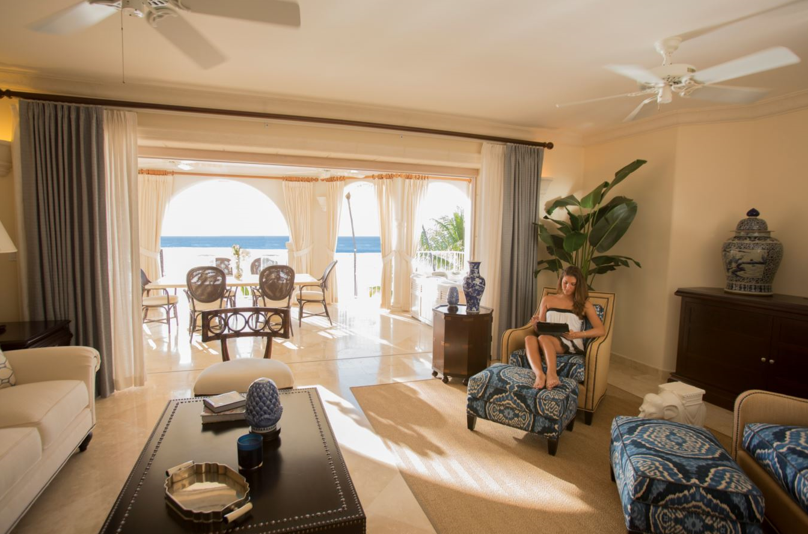

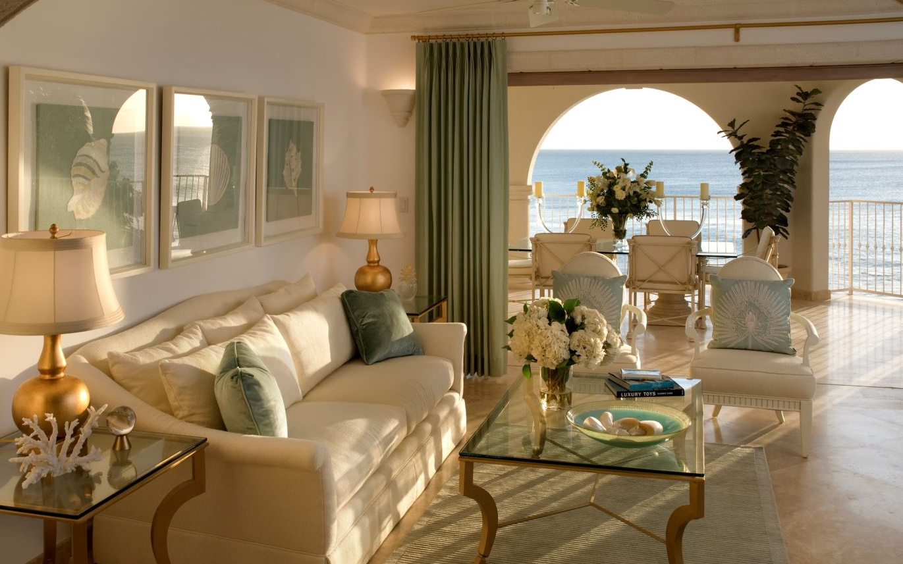

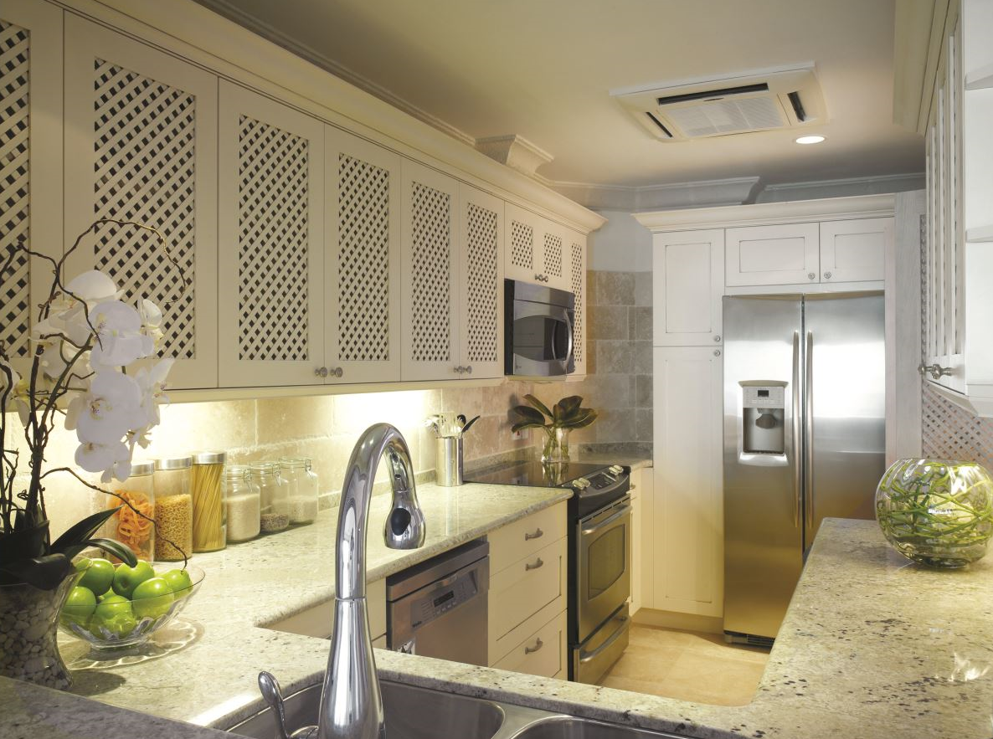

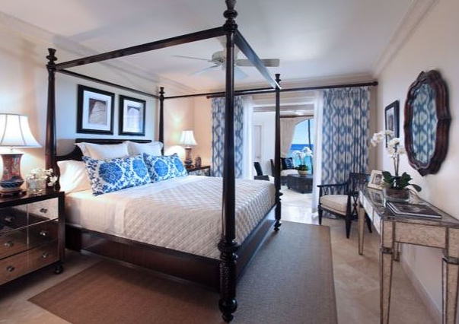

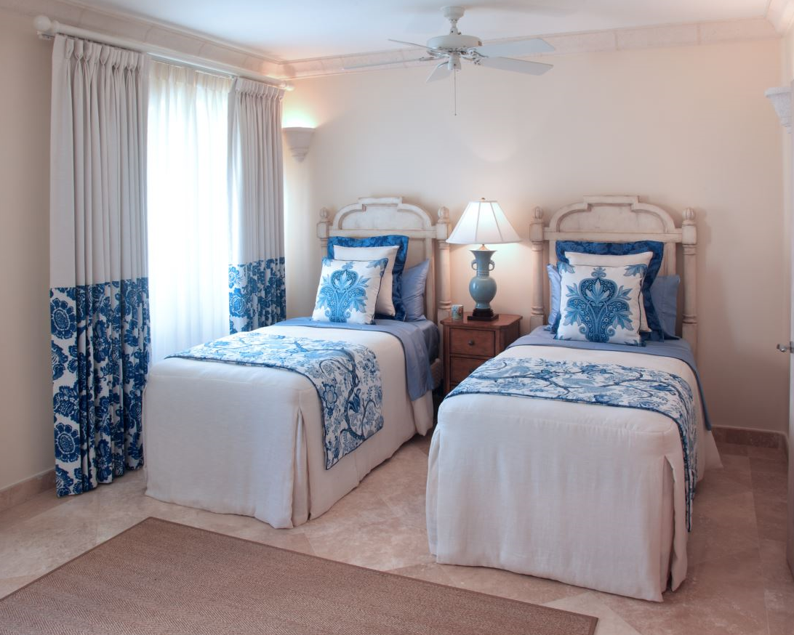

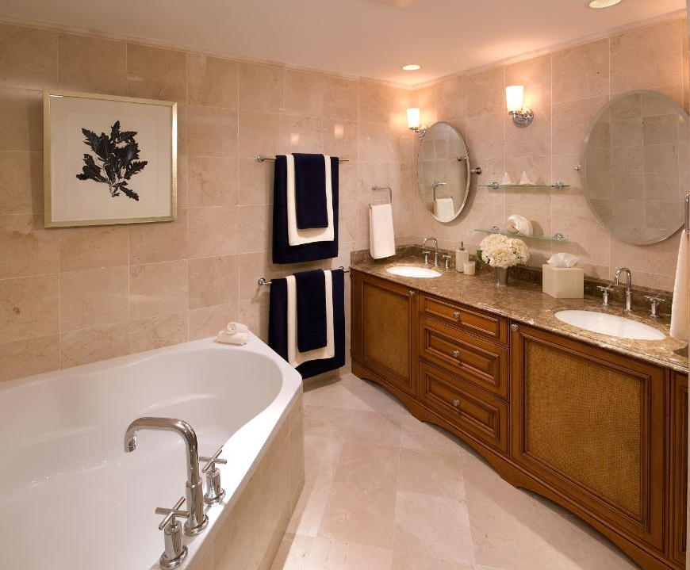

Accommodation

Maximum Guests: 6

Bedrooms: 3

Bathrooms: 3

**About the Property:**

Ideally situated on the island’s northwest coast, which is regarded by many as the ‘Barbados Riviera’. Saint Peter’s Bay features four acres of spacious beachfront enhanced with tropical gardens. This prime location allows homeowners and guests to have convenient access to enjoy and experience all Barbados has to offer, both on land and in the surrounding Caribbean waters.

The three bedrooms homes, featuring approximately 2,700 square feet of space designed for private secluded living, is made up with one master suite and two en suite bedrooms. The ocean views have been maximized with the design boasting sea views from the kitchen, living area, two terraces and both the master and second bedrooms. The property also comes with a fully equipped kitchen and laundry area with large living spaces and terraces with a private spa pool.

**About St Peter’s Bay:**

Homeowners and guests also have access to Port Saint Charles Yacht Club and a range of facilities at the magnificent Port Ferdinand Luxury Marina and Residences.

Water-taxi service is provided between the resort and other three UNNA resort properties, as well as transport to the historic Speightstown and other restaurants and beaches along the famed west coast.

Facilities

* Beach:

Enjoy an invigorating swim in the warm sea on your doorstep, laze on the beautiful white sandy beach with one of the resorts unique cocktails, or join in at sunset, watching the baby turtles as they take their first steps and make their way to the sea. One of the island’s most pristine beaches, Saint Peter’s Bay is a protected wonder attracting marine life, including the majestic Hawksbill turtle and the more common green turtle which lay their eggs on the beach. It is impossible for those seeking the perfect tropical paradise to live or stay here not be enchanted by the magical ever changing sunsets.

* Pool:

Lounge beside the 160 foot long lagoon style pool which meander through the beachfront of the resort providing many poolside areas of privacy. Adjacent to the pool is the gazebo bar, where the friendly barman prepares light snacks and unique cocktails.

* Gazebo Bar:

The cool and breezy gazebo bar provides poolside and beach butler service as well as delicious light lunches. Set overlooking the ocean and pool, this is the perfect spot to relax in the shade during the day, watching the sun set or enjoy an evening barbecue with family, friends and neighbours.

* Personal Trainer:

Saint Peter’s Bay knows the importance of healthy living and healthy lifestyle. Many of the home owners and guests are motivated by the serenity of the resort to book a personal trainer to help them with their fitness regime. With a superb fitness centre they have all the facilities to help you maintain that healthy lifestyle.

* Beauty Salon:

For pure relaxation and pampering, the professionally trained team will treat you to a full range of salon services. From hair styling, colouring and makeovers, to facials, body treatments, manicures and pedicures. Enjoy a soothing massage including stone therapy and aromatherapy in the salon or your home.

* Yoga and Pilates studio:

This is locate beside the fitness centre and offers a variety of classes to help you achieve your health goals

* Gourmet studio:

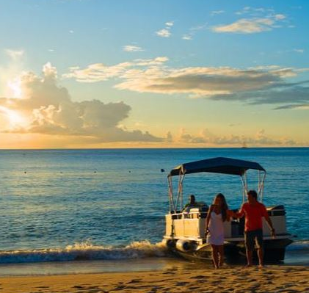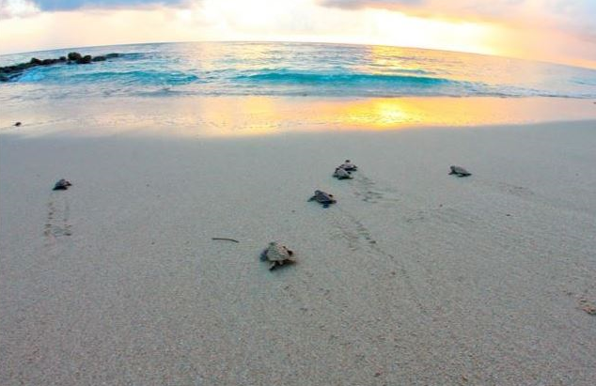The Gourmet store is located a short water taxi ride away at Port Ferdinand Luxury Marina & Residences, one of the sisters UNNA resorts, providing easy access to a selection of fresh and imported produce of the best quality as well as your holiday essentials. Enjoy delicious treats from fresh fruit and seafood to fine wines, cheeses, deli meats, pates, ready-to-go meals, and marinated meats. Join them for breakfast with freshly baked breads, pastries, coffee, fresh fruit juices and smoothies.

*All subject to local taxes (7.5% VAT)